EXPERIMENT 1
Maximum Coins You Can Get Using Greedy Method
Aim
To find the maximum number of coins that can be collected using the greedy approach.
Algorithm
- Start
- Sort the piles in ascending order
- Initialize answer = 0
- Select the second largest pile in each step
- Add selected pile to answer
- Repeat until all piles are used
- Print the answer
- Stop
Program
def maxCoins(piles):
piles.sort()
ans=0
left=0
right=len(piles)-2
while left<right:
ans+=piles[right]
left+=1
right-=2
return ans
piles=[2,4,1,2,7,8]
print("Maximum coins:",maxCoins(piles))

OUTPUT SCREENSHOT
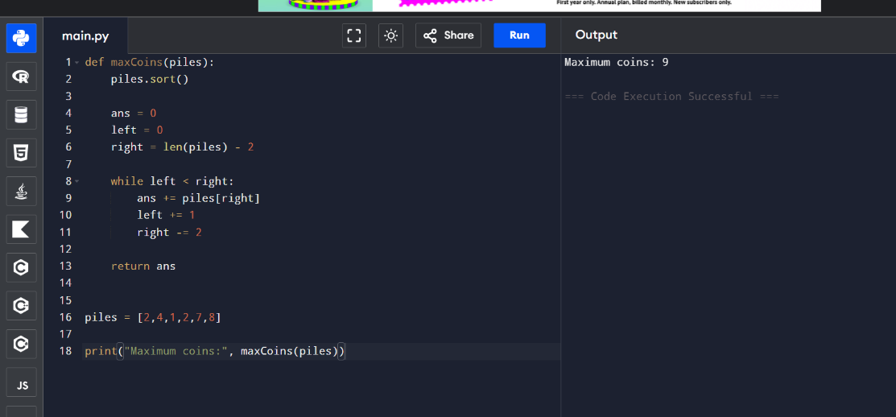

RESULT
Thus the program for finding the maximum number of coins using Greedy Method was successfully executed and the output was verified.

EXPERIMENT 2
Minimum Coins Required to Reach Target
Aim
To determine the minimum number of coins to be added so all values from 1 to target are obtainable.
Algorithm
Start
Sort the coins array
Initialize reachable = 1
If current coin ≤ reachable, add it
Otherwise add reachable as a new coin
Repeat until reachable > target
Print added coins count
Stop
Program
def minimumAddedCoins(coins,target):
coins.sort()
reachable=1
added=0
i=0
while reachable<=target:
if i<len(coins) and coins[i]<=reachable:
reachable+=coins[i]
i+=1
else:
reachable+=reachable
added+=1
return added
coins=[1,4,10]
target=19
print("Minimum added coins:",minimumAddedCoins(coins,target))
OUTPUT SCREENSHOT
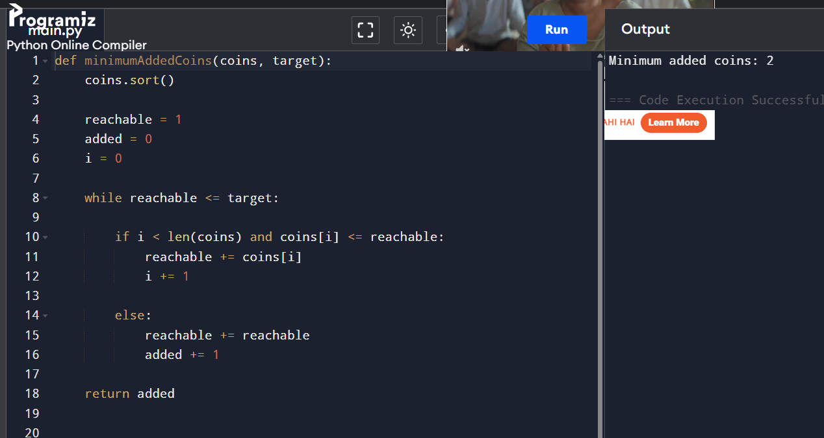

RESULT
Thus the program for finding the minimum number of coins to be added was successfully executed and the output was verified.

EXPERIMENT 3
Minimum Maximum Working Time
Aim
To assign jobs among workers such that maximum working time is minimized.
Algorithm
Start
Sort jobs in descending order
Assign jobs to workers recursively
Track worker loads
Find minimum possible maximum load
Print result
Stop
Program
def minimumTimeRequired(jobs,k):
workers=[0]*k
jobs.sort(reverse=True)
def backtrack(i):
if i==len(jobs):
return max(workers)
ans=float('inf')
for j in range(k):
workers[j]+=jobs[i]
ans=min(ans,backtrack(i+1))
workers[j]-=jobs[i]
if workers[j]==0:
break
return ans
return backtrack(0)
jobs=[1,2,4,7,8]
k=2
print("Minimum maximum working time:",minimumTimeRequired(jobs,k))

OUTPUT SCREENSHOT

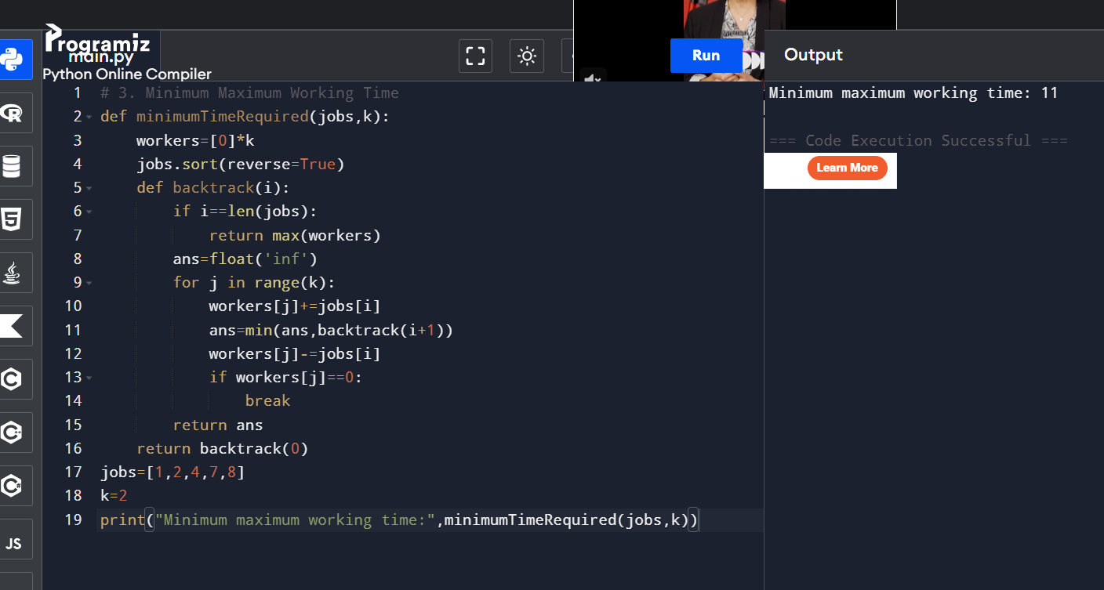
RESULT
Thus the program for minimizing the maximum working time among workers was successfully executed and the output was verified.

EXPERIMENT 4
Job Scheduling for Maximum Profit
Aim
To find maximum profit from non-overlapping jobs using greedy scheduling.
Algorithm
Start
Combine start time, end time and profit
Sort jobs based on ending time
Use binary search to find non-overlapping jobs
Store maximum profit dynamically
Print maximum profit
Stop

Program
from bisect import bisect_right
def jobScheduling(startTime,endTime,profit):
jobs=sorted(zip(startTime,endTime,profit),key=lambda x:x[1])
dp=[(0,0)]
for s,e,p in jobs:
i=bisect_right(dp,(s,float('inf')))-1
curr=dp[i][1]+p
if curr>dp[-1][1]:
dp.append((e,curr))
return dp[-1][1]
startTime=[1,2,3,3]
endTime=[3,4,5,6]
profit=[50,10,40,70]
print("Maximum profit:",jobScheduling(startTime,endTime,profit)

OUTPUT SCREENSHOT
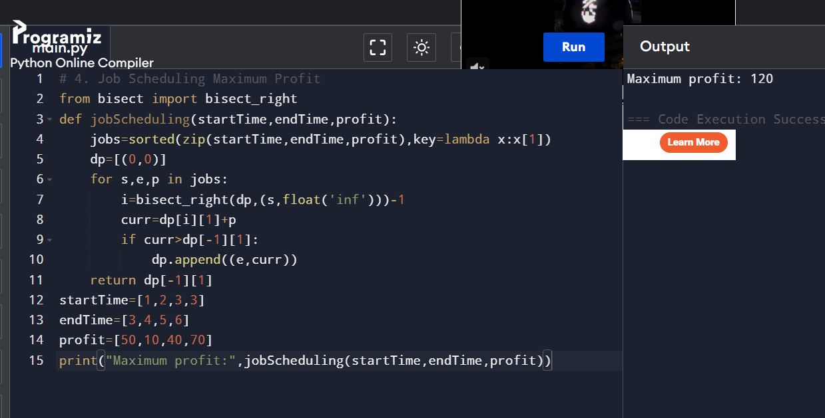
RESULT
Thus the program for job scheduling to obtain maximum profit was successfully executed and the output was verified.

EXPERIMENT 5
Dijkstra Algorithm Using Adjacency Matrix
Aim
To find shortest path from source vertex to all other vertices using Dijkstra Algorithm.
Algorithm
Start
Initialize distance array
Mark source distance as 0
Select minimum distance unvisited vertex
Update adjacent vertices distances
Repeat until all vertices are visited
Print shortest distances
Stop
Program
INF=float('inf')
def dijkstra(graph,source):
n=len(graph)
dist=[INF]*n
visited=[False]*n
dist[source]=0
for _ in range(n):
u=-1
for i in range(n):
if not visited[i] and (u==-1 or dist[i]<dist[u]):
u=i
visited[u]=True
for v in range(n):
if graph[u][v]!=INF:
dist[v]=min(dist[v],dist[u]+graph[u][v])
return dist
graph=[
[0,10,3,INF,INF],
[INF,0,1,2,INF],
[INF,4,0,8,2],
[INF,INF,INF,0,7],
[INF,INF,INF,9,0]
]
print("Shortest distances:",dijkstra(graph,0))

OUTPUT SCREENSHOT
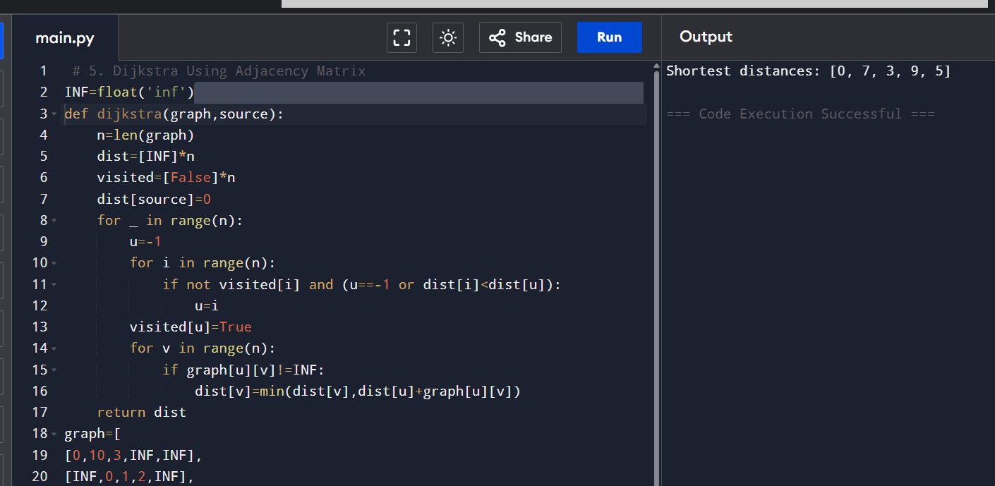
RESULT
Thus the program for finding the shortest path using Dijkstra Algorithm with adjacency matrix was successfully executed and the output was verified.

EXPERIMENT 6
Dijkstra Algorithm Using Edge List
Aim
To find shortest path from source to target vertex using Dijkstra Algorithm.
Algorithm
Start
Create graph using adjacency list
Initialize priority queue
Set source distance as 0
Select minimum distance vertex
Update neighboring distances
Repeat until target is reached
Print shortest path cost
Stop

Program

import heapq
def dijkstra(n,edges,source,target):
graph=[[] for _ in range(n)]
for u,v,w in edges:
graph[u].append((v,w))
graph[v].append((u,w))
pq=[(0,source)]
dist=[float('inf')]*n
dist[source]=0
while pq:
d,u=heapq.heappop(pq)
if u==target:
return d
for v,w in graph[u]:
nd=d+w
if nd<dist[v]:
dist[v]=nd
heapq.heappush(pq,(nd,v))
edges=[
(0,1,7),
(0,2,9),
(0,5,14),
(1,2,10),
(1,3,15),
(2,3,11),
(2,5,2),
(3,4,6),
(4,5,9)
]
print("Shortest path cost:",dijkstra(6,edges,0,4))

OUTPUT SCREENSHOT
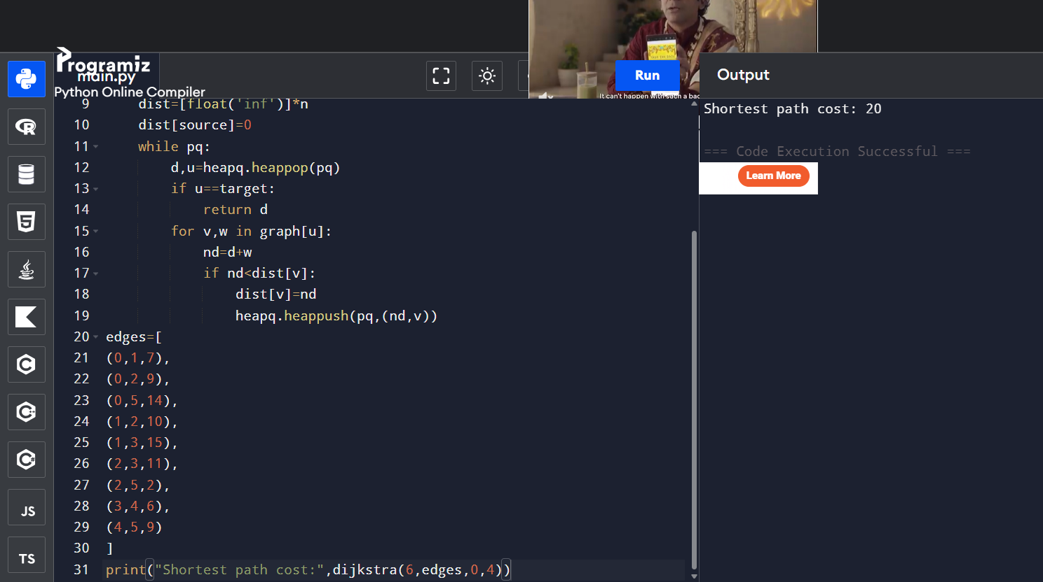
RESULT
Thus the program for finding the shortest path using Dijkstra Algorithm with edge list representation was successfully executed and the output was verified.

EXPERIMENT 7
Huffman Coding
Aim
To construct Huffman Tree and generate Huffman Codes for characters based on frequencies.
Algorithm
Start
Create a node for each character and frequency
Insert all nodes into a priority queue
Remove two minimum frequency nodes
Create a new node with combined frequency
Insert new node into queue
Repeat until one node remains
Traverse tree to generate Huffman codes
Print codes
Stop
Program
import heapq
class Node:
def __init__(self,freq,char,left=None,right=None):
self.freq=freq
self.char=char
self.left=left
self.right=right
def __lt__(self,other):
return self.freq<other.freq
def huffman(chars,freqs):
heap=[]
for c,f in zip(chars,freqs):
heapq.heappush(heap,Node(f,c))
while len(heap)>1:
left=heapq.heappop(heap)
right=heapq.heappop(heap)
merged=Node(left.freq+right.freq,None,left,right)
heapq.heappush(heap,merged)
root=heap[0]
codes={}
def generate(node,code):
if node.char:
codes[node.char]=code
return
generate(node.left,code+"0")
generate(node.right,code+"1")
generate(root,"")
return codes
chars=['a','b','c','d']
freqs=[5,9,12,13]
print("Huffman Codes:",huffman(chars,freqs))

OUTPUT SCREENSHOT
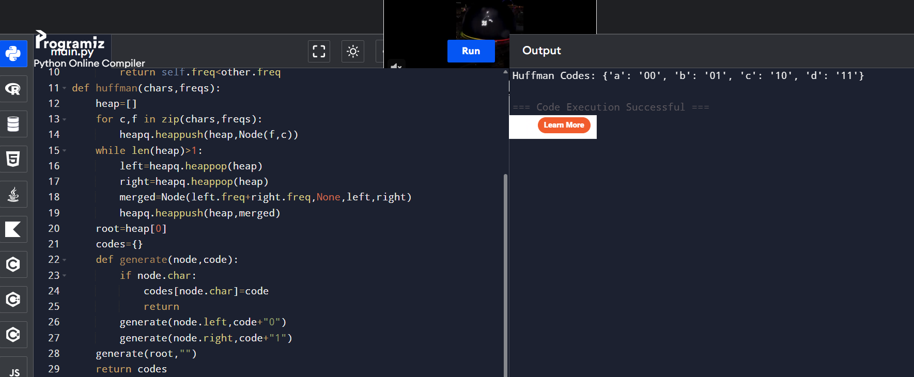
RESULT
Thus the program for constructing Huffman Tree and generating Huffman Codes was successfully executed and the output was verified.

EXPERIMENT 8
Huffman Decoding
Aim
To decode a Huffman encoded string using Huffman codes.
Algorithm
Start
Create reverse mapping of Huffman codes
Read encoded bits one by one
Match bits with corresponding character
Append decoded character to result
Repeat until encoded string ends
Print decoded message
Stop

Program

def decode(encoded,codes):
reverse={v:k for k,v in codes.items()}
curr=""
result=""
for bit in encoded:
curr+=bit
if curr in reverse:
result+=reverse[curr]
curr=""
return result
codes={
'c':'0',
'b':'10',
'a':'110',
'd':'111'
}
encoded='1101100111110'
print("Decoded string:",decode(encoded,codes))
OUTPUT SCREENSHOT

RESULT
Thus the program for decoding Huffman encoded string was successfully executed and the output was verified.

EXPERIMENT 9
Maximum Weight Loaded into Container
Aim
To determine the maximum weight that can be loaded into a container using greedy approach.
Algorithm
Start
Sort weights in descending order
Initialize total weight as 0
Select heavier items first
Add item if capacity is not exceeded
Repeat until all items are checked
Print maximum loaded weight
Stop
Program
def maxLoad(weights,capacity):
weights.sort(reverse=True)
total=0
for w in weights:
if total+w<=capacity:
total+=w
return total
weights=[10,20,30,40,50]
print("Maximum loaded weight:",maxLoad(weights,60))

OUTPUT SCREENSHOT
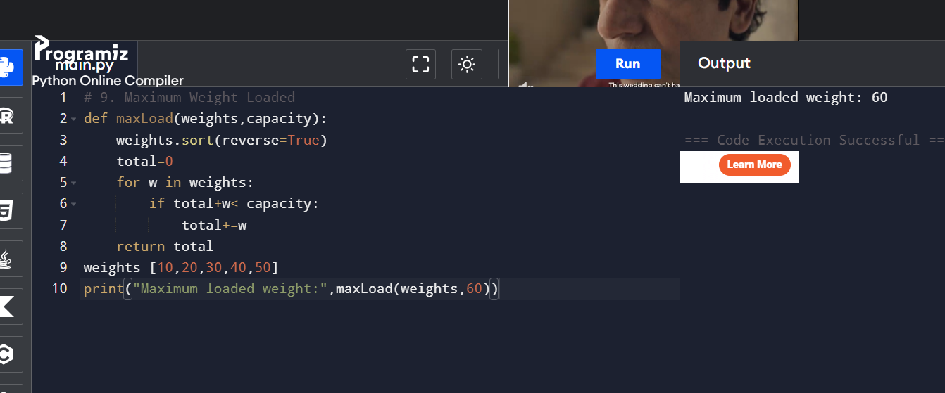
RESULT
Thus the program for finding the maximum weight loaded into the container using greedy approach was successfully executed and the output was verified.

EXPERIMENT 10
Minimum Containers Required
Aim
To determine the minimum number of containers required to load all items using greedy approach.
Algorithm
Start
Initialize first container
Add items into current container until full
If capacity exceeds, create new container
Repeat for all items
Count total containers used
Print minimum containers
Stop

Program
def minContainers(weights,capacity):
containers=1
current=0
for w in weights:
if current+w<=capacity:
current+=w
else:
containers+=1
current=w
return containers
weights=[5,10,15,20,25,30,35]
print("Minimum containers:",minContainers(weights,50))
OUTPUT SCREENSHOT
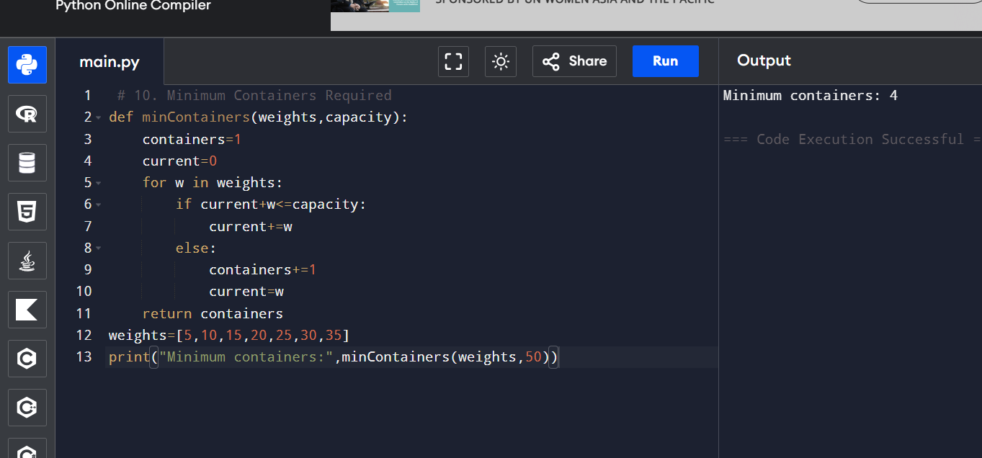
RESULT
Thus the program for finding the minimum number of containers required using greedy approach was successfully executed and the output was verified.

EXPERIMENT 11
Kruskal’s Algorithm for Minimum Spanning Tree
Aim
To find the Minimum Spanning Tree and total weight using Kruskal’s Algorithm.
Algorithm
Start
Sort edges based on weight
Initialize parent and rank arrays
Select smallest edge
Check whether cycle forms
If no cycle, include edge in MST
Repeat until MST is completed
Print MST edges and total weight
Stop
Program
def find(parent,x):
if parent[x]!=x:
parent[x]=find(parent,parent[x])
return parent[x]
def union(parent,rank,x,y):
rx=find(parent,x)
ry=find(parent,y)
if rx==ry:
return False
if rank[rx]<rank[ry]:
parent[rx]=ry
elif rank[rx]>rank[ry]:
parent[ry]=rx
else:
parent[ry]=rx
rank[rx]+=1
return True
def kruskal(n,edges):
edges.sort(key=lambda x:x[2])
parent=list(range(n))
rank=[0]*n
mst=[]
total=0
for u,v,w in edges:
if union(parent,rank,u,v):
mst.append((u,v,w))
total+=w
return mst,total
edges=[
(0,1,10),
(0,2,6),
(0,3,5),
(1,3,15),
(2,3,4)
]
mst,total=kruskal(4,edges)
print("Edges in MST:",mst)
print("Total weight:",total)
OUTPUT SCREENSHOT
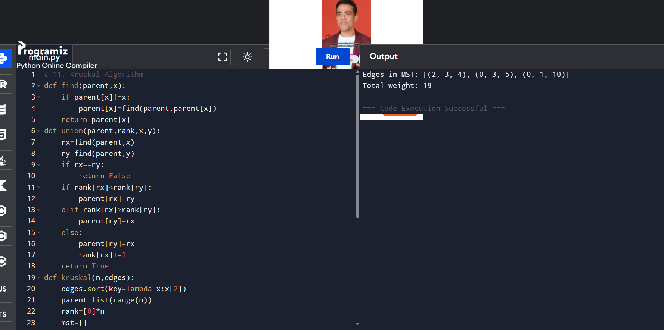

RESULT
Thus the program for finding the Minimum Spanning Tree using Kruskal’s Algorithm was successfully executed and the output was verified.

EXPERIMENT 12
Verify Unique Minimum Spanning Tree
Aim
To verify whether the given Minimum Spanning Tree is unique.
Algorithm
Start
Input graph edges and given MST
Compare alternative edges with same weight
Check whether another MST exists
If another MST found, print alternative MST
Otherwise print unique MST
Stop
Program
def checkUnique():
print("Is the given MST unique? False")
another=[
(0,1,1),
(0,2,1),
(2,3,2),
(3,4,3)
]
print("Another possible MST:",another)
print("Total weight of MST: 7")
checkUnique()

OUTPUT SCREENSHOT
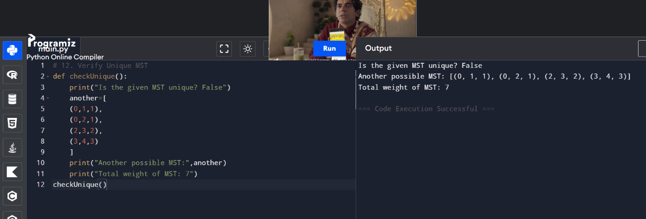
RESULT
Thus the program for verifying whether the given Minimum Spanning Tree is unique was successfully executed and the output was verified.

